Brice Baerga

October 21, 2020

Artificial Intelligence

Easy NN Assignment

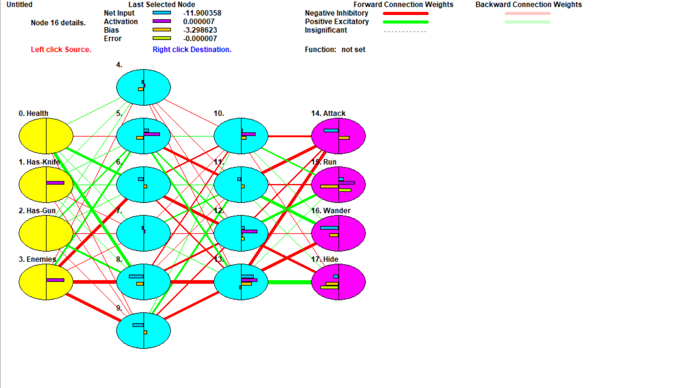

1. How many hidden layers did you use?
   1. I used two hidden layers within this neural network. One hidden layer seemed to produce an infinite number of cycles.
2. Did you need to increase the number of hidden layers to get the network to train properly?
   1. I did have to increase the number of hidden layers in order to get this network trained properly. At first, using only one hidden layer yielding infinite cycles. The results never seemed to reach 0, and in addition to that the maximum, average, and minimum seemed to stay completely stagnant. This stayed true even past 1,000,000 cycles, which led me to add more. It seemed only that when there was an addition of a second hidden layer that the results became more prominent and final.
3. Did the network train slowly?
   1. The network trained slowly only whenever there was a lack of a second hidden layer. The network seemed to train infinitely, even passing 4,000,000 cycles. However, whenever I added in the second layer, the network seemed to train almost instantaneously, doing so within 201 cycles.
4. Once trained, did your network produce the correct outputs 100%?
   1. The network seemed to produce the correct outputs 100%. With 7 validating examples placed in the grid, the network got a correct if rounded score of 7, leading me to believe that all of the outputs produced for the network were 100% correct.